Project

Final Report

|  |  |
| --- | --- |
| Document Information | |
| Course Title | Electronics Design I |
| Course Code | ELET 2405 |
| Date | December 1, 2023 |
| Student ID | 620157646 |

**TABLE OF CONTENTS**

**Chapter Page Number**

Abstract 3

Introduction 4

Description and Specification 5 – 6

The Hardware Design 7 – 16

Hardware Block Design 8

Hardware Schematic and PCB Diagrams 9 – 10

Prototype and Final PCB Set Up 11 – 12

Power Supply and Battery Backup 13

Bill of Materials 14 - 16

The Software Design 17 – 24

Software State Diagram 18

Flow Charts 19 – 24

Methodology and Findings 25 - 31

Steps and Procedure 26

Analysis and Discussion 26

Limitation and Precaution 26

Results from Combining the Hardware and Software 27 - 31

Conclusion 32

References 33

**ABSTRACT**

The purpose of this project report is to demonstrate the design and development of an AVR microcontroller-based digital clock. In order to complete the project, specifications must be created. These must include the use of an alphanumeric LCD display with the ability to display six digits (two for hours, two for minutes, and two for seconds), function in both 12 and 24 hour modes at all times on a 110V JPS mains or the battery backup, and have features like reset, set, and alarm functions. A group of outside tactile switches are used to access these functions.

**INTRODUCTION**

The idea of relative time, which may be seen differently by observers in motion relative to one another, was first articulated in Albert Einstein’s theory of special relativity in 1905. Humans have long sought a means to precisely measure and keep track of time ever since it was discovered. Although primarily focused on theoretical aspects of time and its relationship with space, Einstein's contributions significantly impacted our comprehension of clocks, time measurement, and their connection to the fundamental principles of the universe.

Unlike conventional analog clocks, which indicate time with hour and minute hands, digital clocks display the time in a numerical manner using digits. Digital clocks are used in a variety of settings including homes, businesses, public areas and technological gadgets because they give a clear and easy-to-read depiction of the time. The majority of digital clocks are microcontroller-based, which makes them more compact, effective, and functionally versatile than earlier models.

This project is a digital clock that operates based on the instructions programmed into the ATtiny4313 microcontroller, which is a dependable and programmable computational device, and displays the time with an accuracy of one second to the 16x2 Alphanumeric LCD display. The system has the ability to function in either 12 or 24 hours mode at all times on a 110V JPS mains or the battery backup, an audible buzzer for alarms and an LCD to display time. The clock also has features such as reset, set time, set alarm time, disable alarm, snooze and display a motivational message. A group of outside tactile switches are used to access these functions.

**DESCRIPTION AND SPECIFICATION**

A digital clock is one that uses a display to show time in digital format. For this project, a 16x2 Alphanumeric LCD module will be used to display the. The display will allow six digits in the format of HH:MM:SS to be shown. The LCD is interfaced with ATtiny4313 microcontroller. The clock is a compact, lightweight, handheld gadget that can execute the fundamental operations of a digital clock, such as changing modes, setting the time or an alarm, resetting the time, and having a snooze option. In particular, it needs to be portable, be able to maintain precise timing with an accuracy of one second, and include eight buttons: one to reset the time, one to display normal clock state or turn off the buzzer, one to switch between modes, one to set the time, one to set an alarm time, one to disable the alarm or increment the hours, one to snooze or increment the minutes and one to display a motivational message or increment the seconds.

**Operation:** The time is displayed on the LCD screen after the clock has be switched on and increments as time elapses. By utilizing the built-in delay feature, the seconds portion of the display increased after each second. When the seconds part of the display reached 59, the minutes part of the display incremented by one and the seconds part had reset to 0. Similarly, as the minutes part reached 59, the hours part increased by one and the minutes part had reset to 0. While in the 12 hour mode, after the hours part reached 11, the minutes part reached 59 and the seconds part reached 59, the display had set to 12:00:00 and the AM/PM changed to PM/AM respectively. While in the 24 hour mode, after the hours part reached 23, the minutes part reached 59 and the seconds part reached 59, the display had set to 00:00:00.

**Power Source:** The clock operates primarily from the 110V JPS. A voltage regulator is used to step down the voltage to 5V to power the circuit. Additionally, the clock features a battery backup to ensure continuous operation in the event of a power outage.

**Reset:** If in the 12 hours mode, when the reset button is pressed, the default time is 12:00:00 PM, however, in the 24 hours mode, the default time is 12:00:00.

**Change Mode:** This digital clock can operate in either the 12 or 24 hour modes. The user is able to switch between modes by pressing a button. This is configured by programming the ATtiny4313 microcontroller.

**Set Time:** The user is allowed to set the time on the LCD display after pressing the set time button. The user is able to adjust the clock's hours, minutes and seconds by repeatedly pushing the corresponding switches until the desired values are achieved.

**Set Alarm:** The user is allowed to set their desired alarm time on the LCD display after the set alarm time button is pressed. The hours, minutes and seconds of the clock may be adjusted by the user, and this would be done by repeatedly pressing the corresponding switches. After setting the alarm, when the clock display matches the desired time, the buzzer will begin to ring constantly until the user silences the alarm by pushing one of the buttons.

**Snooze:** The user is able to add five minutes to their original alarm time once the snooze switch is pressed.

**Display Motivational Message:** The user is able to display a motivational message nce the corresponding switch is pressed.

**THE HARDWARE DESIGN**

**HARDWARE BLOCK DESIGN**

To satisfy the aforementioned requirements, a Hardware Block Diagram was made to provide a basic understanding of some of the important components that are being interfaced with the ATtiny4313 microcontroller. The KiCad 7.0 program was also used to generate the hardware schematic diagram. A potential block diagram for the digital clock is shown in the image below. Here, an LCD serves as the display, a microcontroller serves as the brain, and buttons serve as input devices. The quantity of I/O lines required to connect to the microcontroller and the power supply required for operation are also displayed. To guarantee that the following requirements are fully satisfied, the Digital Clock Hardware Block Diagram is utilized to identify the precise parts that will be connected to and interacted with the microcontroller.

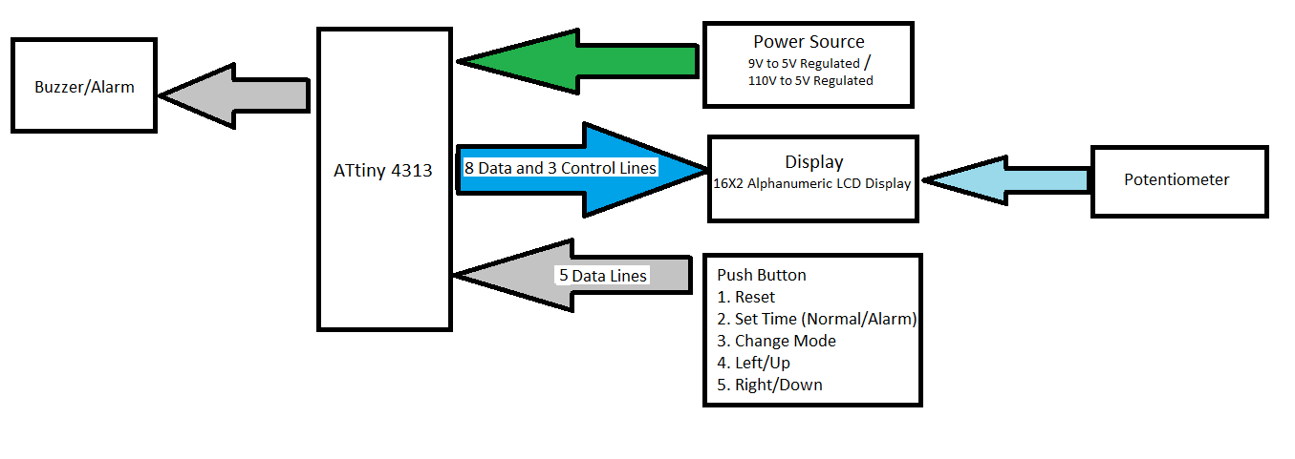

Push Buttons

1. Reset
2. Display Normal Clock State/Turn off Buzzer
3. Change Mode
4. Set Time
5. Set Alarm Time
6. Disable Alarm/Increment Hours
7. Snooze/ Increment Minutes
8. Motivational Message/Increment Seconds

8 Data Lines

**Figure 1.** Hardware Block Diagram of Digital Clock System

**HARDWARE SCHEMATIC AND PCB DIAGRAMS**

Subsequently, schematics and PCB layouts for this digital clock were drafted and revised (as the program evolved) using the KiCad Suite until the final schematic (Figures 2 and 3) and PCB layout (Figure 4) below were plotted.

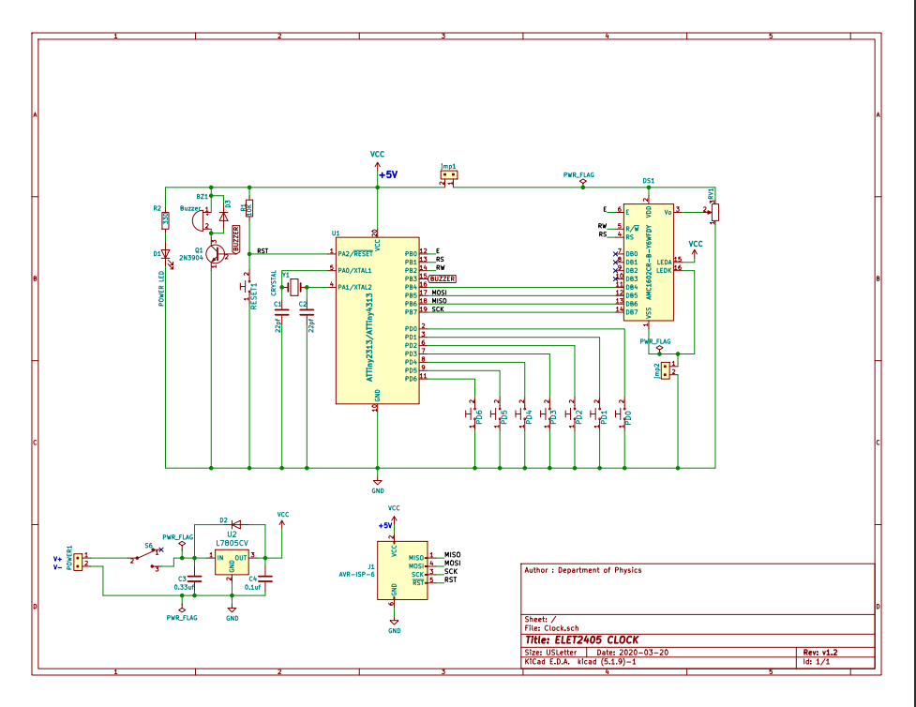

**Figure 2:** Digital Clock Circuit Schematic Diagram

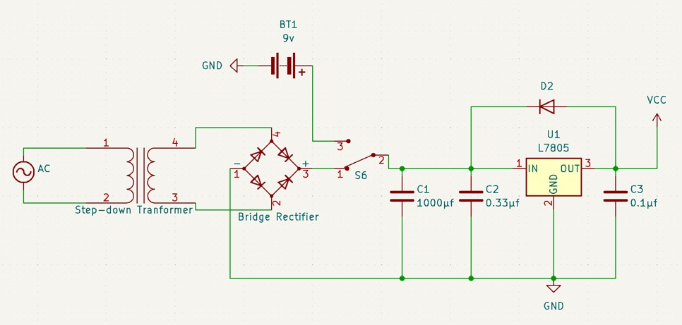

**Figure 3:** Power Supply and Battery Backup Circuit Schematic Diagram

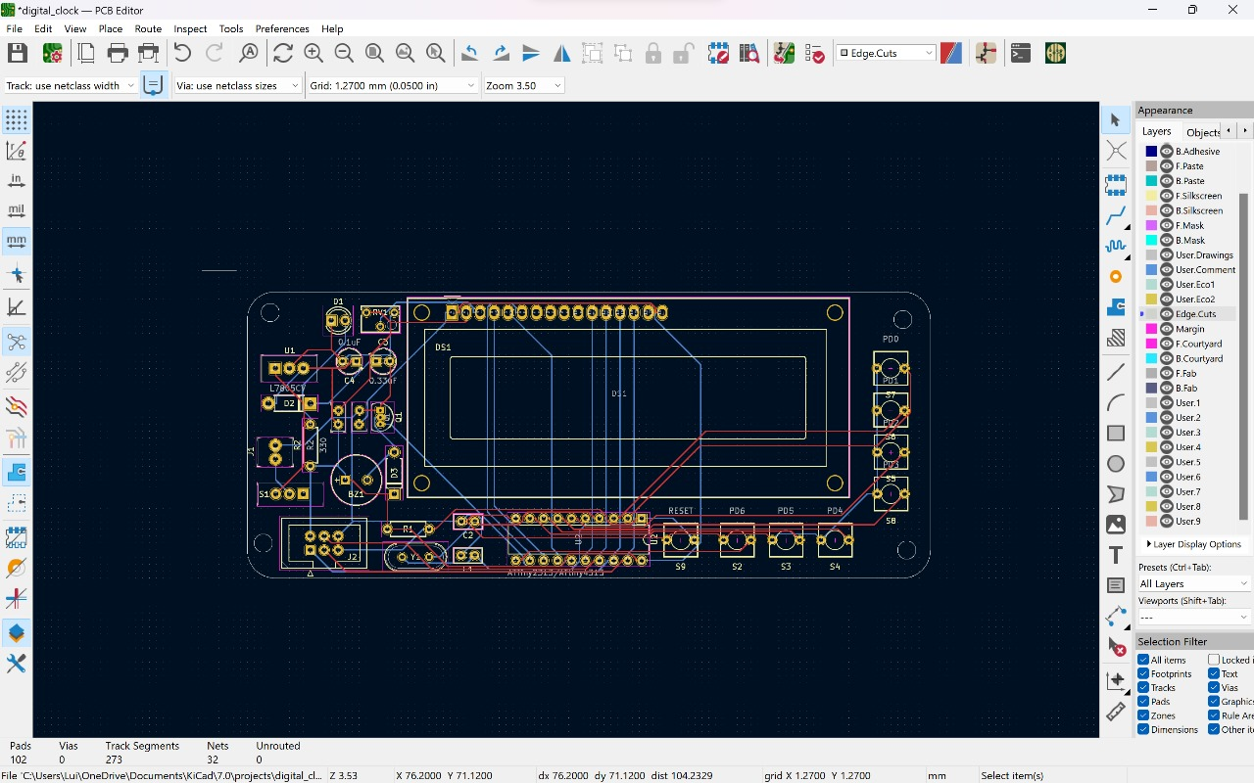

**Figure 4:** Digital Clock Circuit PCB Layout

**PROTOTYPE AND FINAL PCB SET UP**

From the schematics and PCB layouts for this digital clock, the prototype (Figure 5) and final PCB set up (Figures 6 and 7) were created using electronic components from the digital clock project kit.

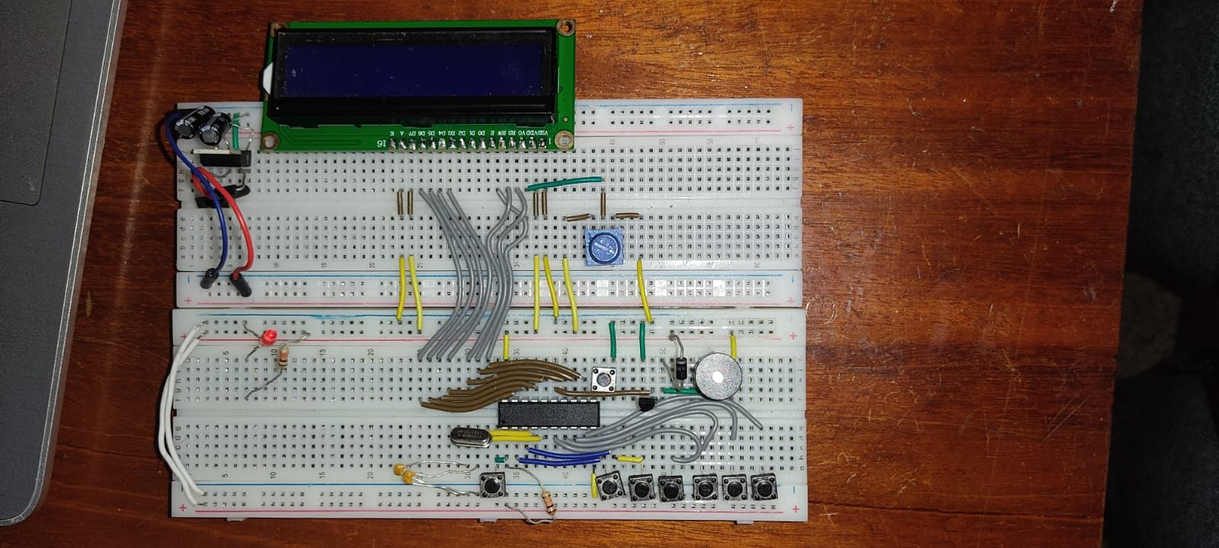

**Figure 5:** Digital Clock Prototype Set Up

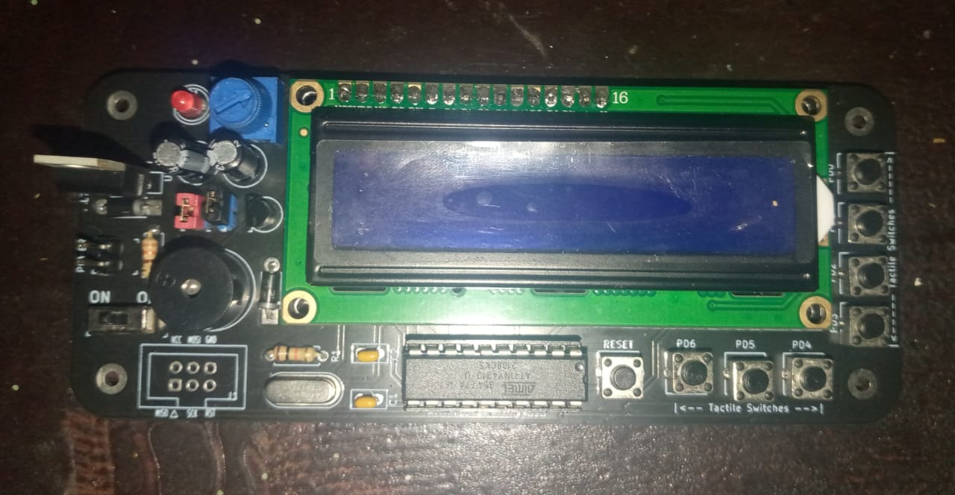

**Figure 6:** Digital Clock PCB Set Up (Top View)

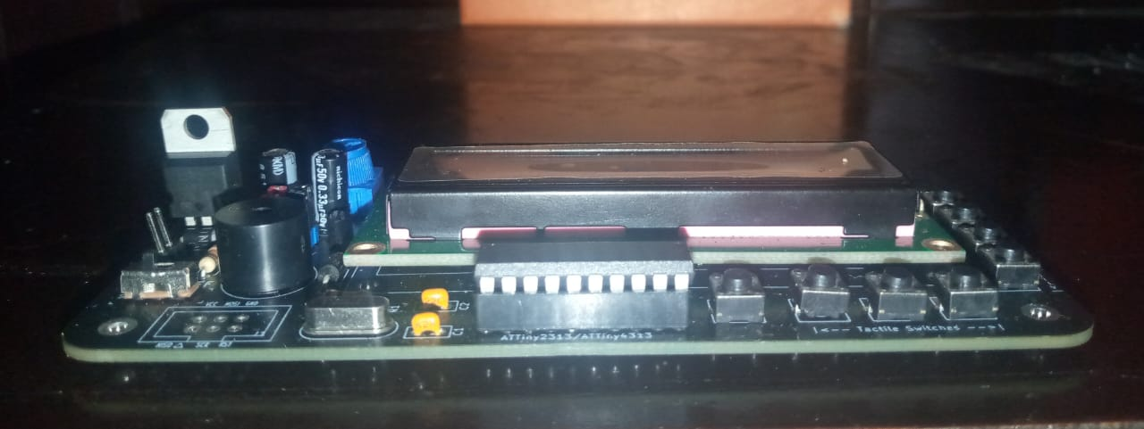

**Figure 7:** Digital Clock PCB Set Up (Side View)

**POWER SUPPLY AND BATTERY BACKUP**

The project also required a setup of a power supply and a backup battery. The battery backup is crucial for the digital clock to operate during power outages. The setup utilizes a slide switch to create two isolated paths for current to travel into the circuit via a 5V regulator using a 12V dc power supplied by a bridge rectifier circuit created using four 1N4007 diodes, since diodes do not permit the flow of current in the opposite direction, along with a 9V battery. Hence, the current of the main 12V dc power supply does not flow into the 9V battery thus preventing damage to the battery and providing 2 sources for power.

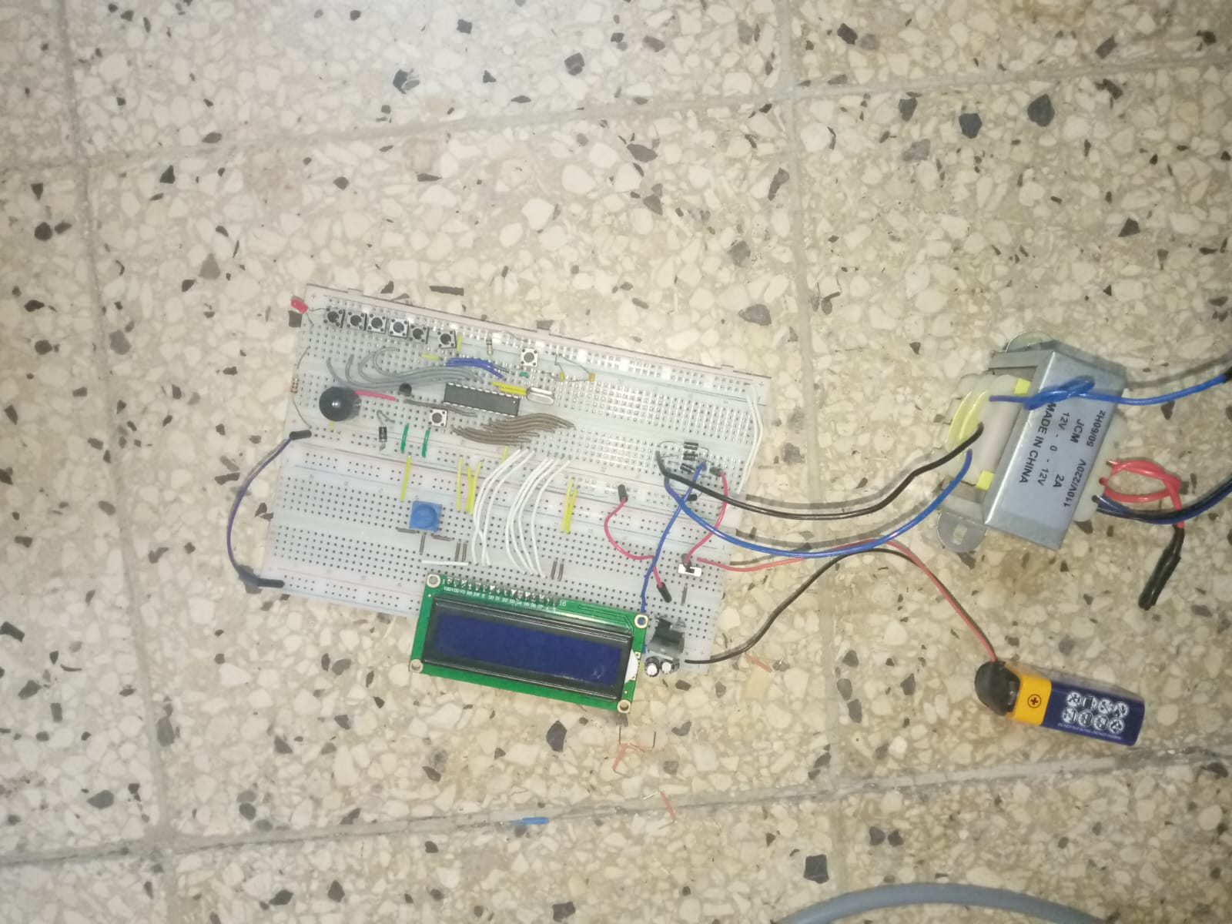

**Figure 8:** Digital Clock with Power Supply and Battery Backup

**BILL OF MATERIALS**

|  |  |  |  |
| --- | --- | --- | --- |
| Table 1 – Equipment and Components Required for Digital Clock Project | | | |
|  | Items | Quantity | Price Per Unit ($) |
| Equipment: | Pololu AVR USB programmer or any other hardware programmer capable of programming 8-bits AVR microcontrollers. | 1 | 3,500.00 |
| Computer loaded with Microchip Studio 7 and KiCad. | 1 |  |
| Soldering Iron | 1 | 500.00 |
| Components | ATtiny2313A or ATtiny4313 AVR Microcontroller | 1 | 450.00 |
| 16x2 Alphanumeric LCD | 1 | 1,250.00 |
| L7805CV (+5V) Voltage regulator | 1 | 100.00 |
| 9V Battery | 1 | 738.83 |
| 12V Power Supply (Step Down Transformer) | 1 |  |
| Red LED | 1 | 50.00 |
| Push Button Switch | 8 | 320.00 |
| 0.33 µF capacitor | 1 | 75.00 |
| 0.1 µF capacitor | 1 | 75.00 |
| 22 pF capacitor | 2 | 75.00 |
| 330 Ω resistor | 1 | 30.00 |
| 10k Ω resistor | 1 | 30.00 |
| Quartz Crystal Oscillator , between ( 8 – 20 MHz) | 1 | 100.00 |
| Sliding Switch(3 Pin) | 2 | 400.00 |
| 10kΩ Potentiometer | 1 | 200.00 |
| 1N4007 Diode | 7 | 175.00 |
| 20pin DIP Socket | 1 | 100.00 |
| 2 Pin Header (Male) | 1 |  |
| 16 Pin Header (Male) | 1 | 200.00 |
| 16 Pin Header (Female) | 1 | 200.00 |
| Buzzer | 1 | 200.00 |
| 2N3904 Transistor | 1 | 75.00 |
| Solder Wire | 3ft | 500.00 |
| PCB Clock Board | 1 | 500.00 |

**THE SOFTWARE**

**DESIGN**

**SOFTWARE DESIGN**

The software uploaded to the ATtiny4313 microcontroller had to be correctly constructed and debugged in order to precisely perform the objectives and function as intended because the Digital Clock runs on the ATtiny4313 microcontroller's instructions, and any faults would be shown on the LCD. The transition from prototype to the final phase of the project, these items and software were found necessary to complete this project. The Pololu USB AVR programmer was required to program the microcontroller using Atmel Studio 7.

***Software state diagram***

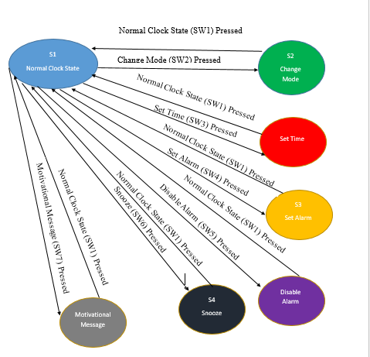

**Figure 9:** The Interaction and Communication of the Different States

***Flow Charts***

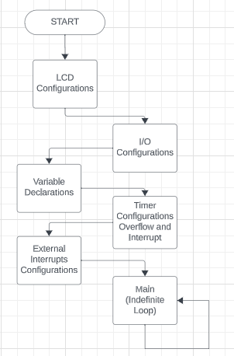

**Figure 1**0: The General Operations of the Digital Clock

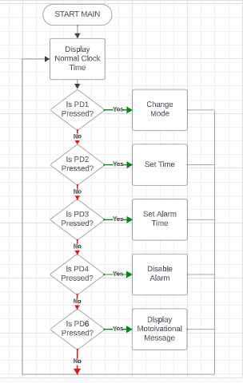

**Figure 1**1: The Logical Operations of the Digital Clock

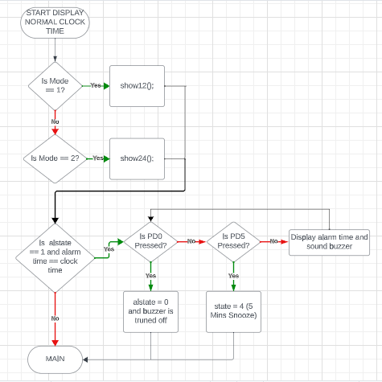

**Figure 12:** The “Display Normal Clock Time” Process

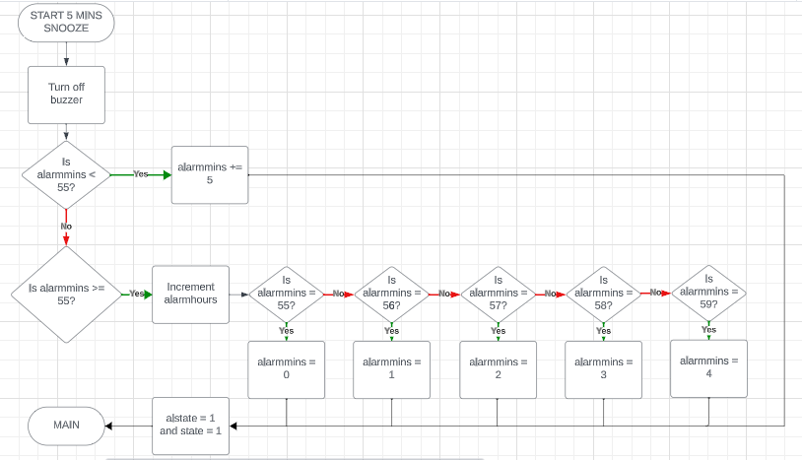

**Figure 13:** The “5 Mins Snooze” Process

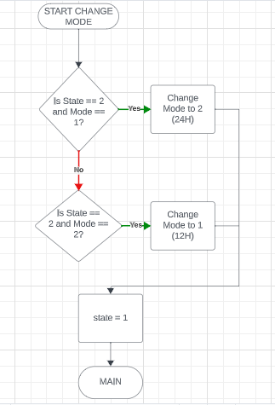

**Figure 14:** The “Change Mode” Process

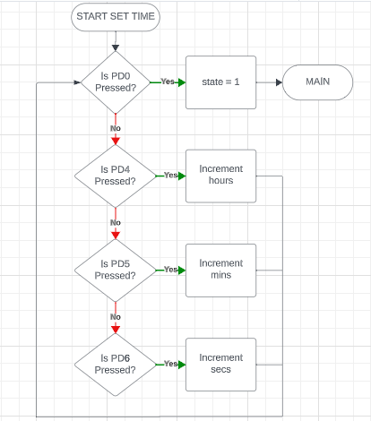

**Figure 15:** The “Set Time” Process

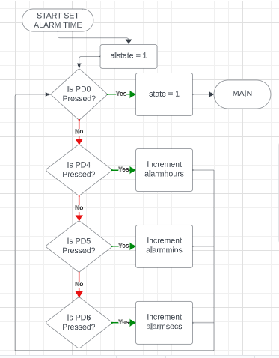

**Figure 16:** The “Set Alarm Time” Process

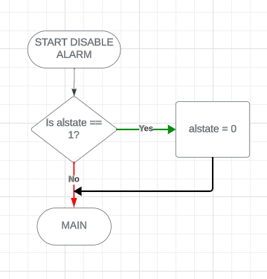

**Figure 17:** The “Disable Alarm” Process

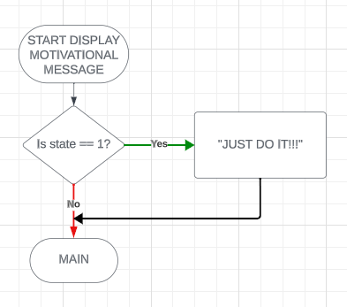

**Figure 19:** The “Display Motivational Message” Process

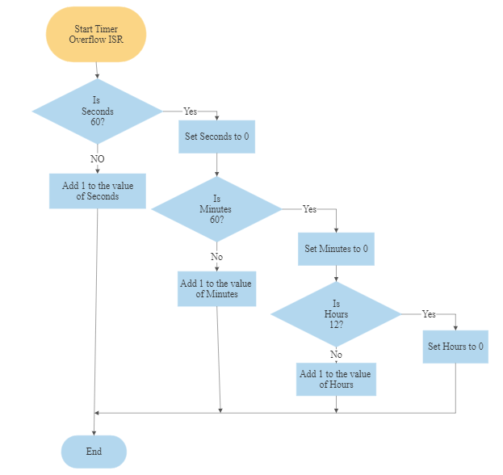

Set Hours to 1

Is Hours 13?

**Figure 20:** Interrupt Service Routine for Digital Clock in 12 Hour Mode

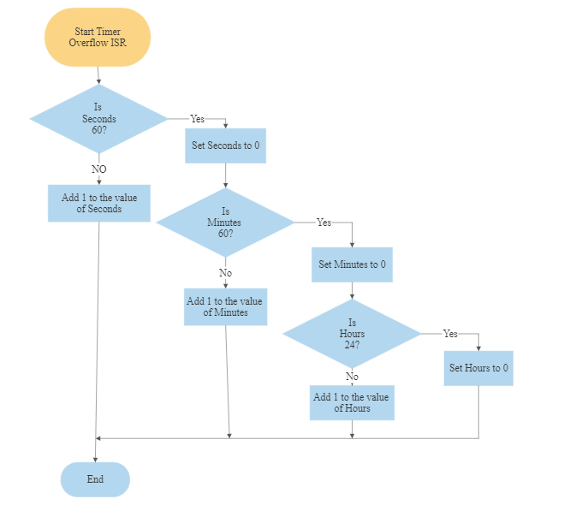

**Figure 21:** Interrupt Service Routine for Digital Clock in 24 Hour Mode

**METHODOLOGY AND FINDINGS**

**STEPS AND PROCEDURE**

The hardware prototype was first assembled in order to have a functional clock to test the code on. After developing the code, the prototype was also used to construct the power supply and battery backup circuit. After these essential components of the digital clock were completed, the final pcb set up was developed from the digital clock prototype. In regards to the digital clock’s hardware, to guarantee that the all requirements were fully satisfied, the Digital Clock Hardware Block Diagram was utilized to identify the precise parts that were connected to and interacted with the microcontroller. Afterwards, a schematic diagram was created to identify the connection lines between the components. From the schematic diagram, a pcb layout was then generated. Afterwards, the power supply and battery backup circuit was created. In regards to the software aspects of the clock, The normal features of a digital clock were firstly developed, such as to change mode, set the time, set an alarm, disable an alarm and turn off the buzzer. Secondly, the added features, such as snooze and the motivational message, were developed.

**ANALYSIS AND DISCUSSION**

A coding challenge that was faced was that the LCD was not displaying the alarm time when the alarm was disabled. After setting the alarm, users should be able to disable the alarm. This provided room for flexibility. While attempting to develop this feature, on the first trial, after disabling the alarm, the normal clock time would skip the time that was set for the alarm before it was disabled. This problem was due to logic error in the if statement of state one. This was corrected by removing a certain condition that was in the if statement to allow the normal clock time to display the alarm time even when it was disabled. A hardware challenge was correctly connecting the electronic components and connecting the battery backup and power supply properly so that they would not affect each other. This problem was solved by using diodes to prevent current from the power supply from interfering with the battery and the current from the battery from interfering with the power supply set up.

**LIMITATION AND PRECAUSTION**

There are no limitations as the clock works as intended and is fully operational. However, one should be cautious when working with alternating current and wear protective gears when doing so. One should also wear masks when soldering as the fumes are dangerous. One should ensure to test for continuity on the pcb before soldering on any components to ensure that the components are correctly oriented on the pcb.

**RESULTS FROM COMBINING THE HARDWARE AND SOFTWARE**

The Buzzer is required to sound when the alarm criteria is met, the potentiometer is required to control the contrast of the LCD for better visibility of characters. The crystal is required for crating the 1 second precision timing, the transistor acts as a switch to the buzzer once the alarm time has passed. The diodes and regulator are used to protect the ATtiny4313 and the LCD as voltages higher than 5.5V could permanently damage these devices.

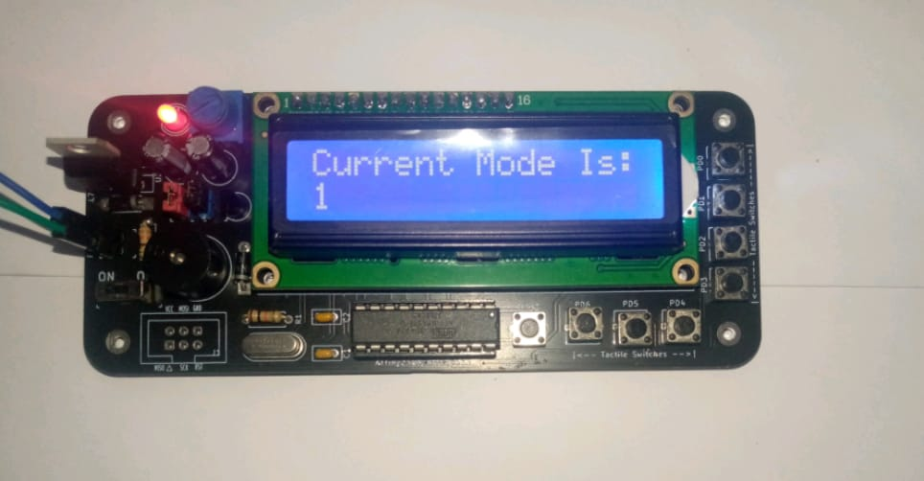

**Figure 22:** Digital Clock Displaying in the 12 Hour Mode

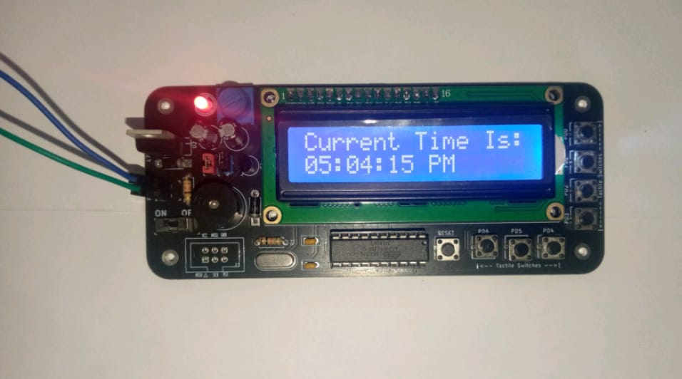

**Figure 23:** Digital Clock Displaying 05:04:15 PM in 12 Hour Mode

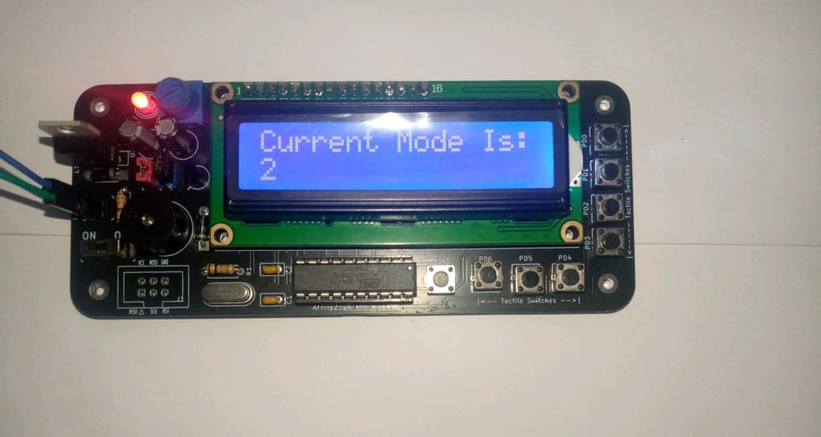

**Figure 24:** Digital Clock Displaying in the 24 Hour Mode

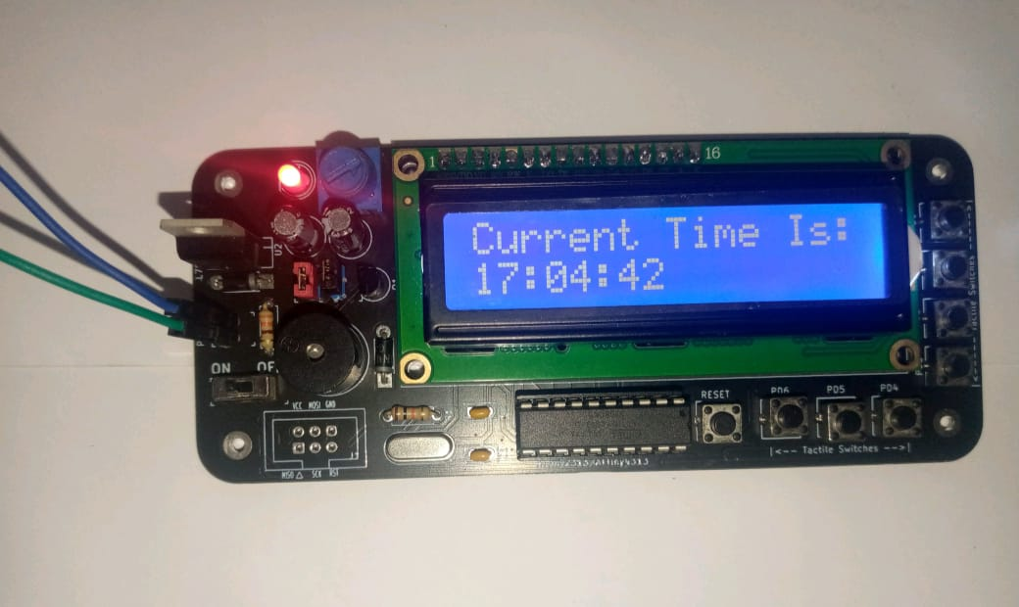

**Figure 25:** Digital Clock Displaying 17:04:42 in 24 Hour Mode

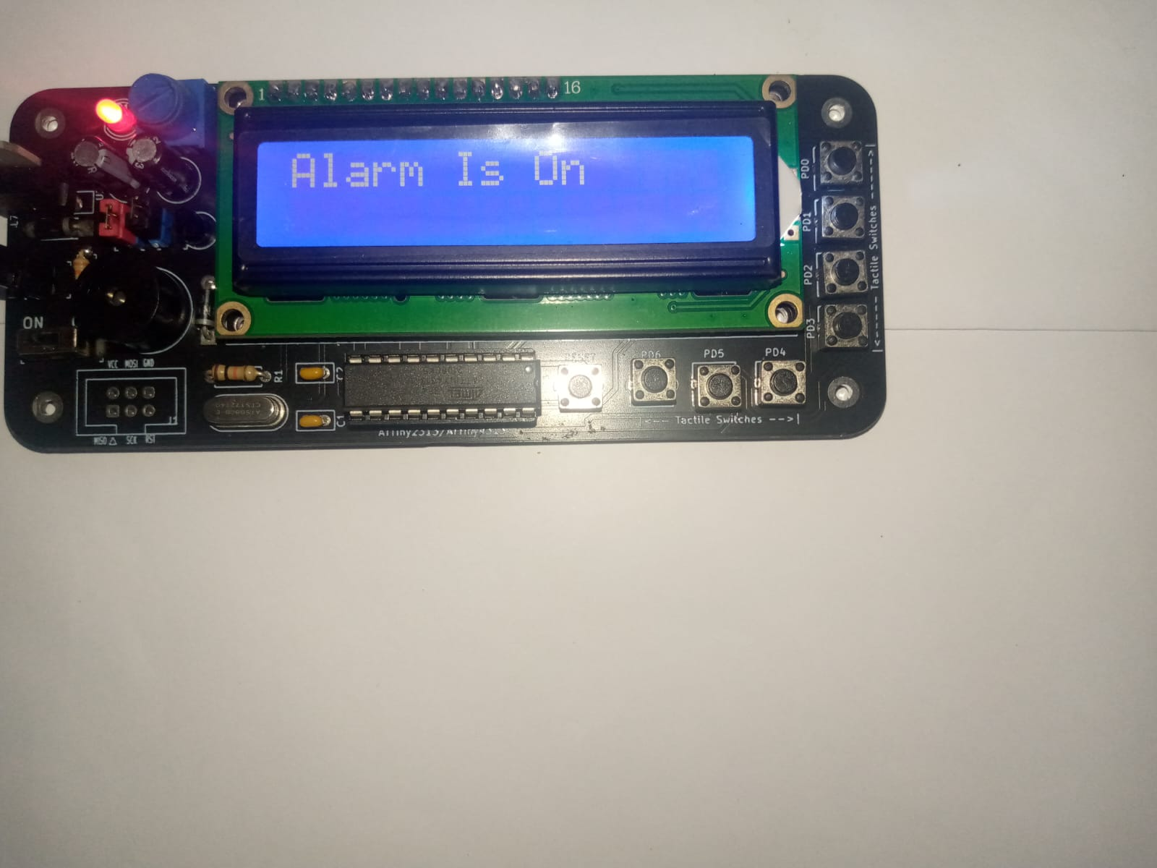

**Figure 26:** Digital Clock Displaying “Alarm Is On”

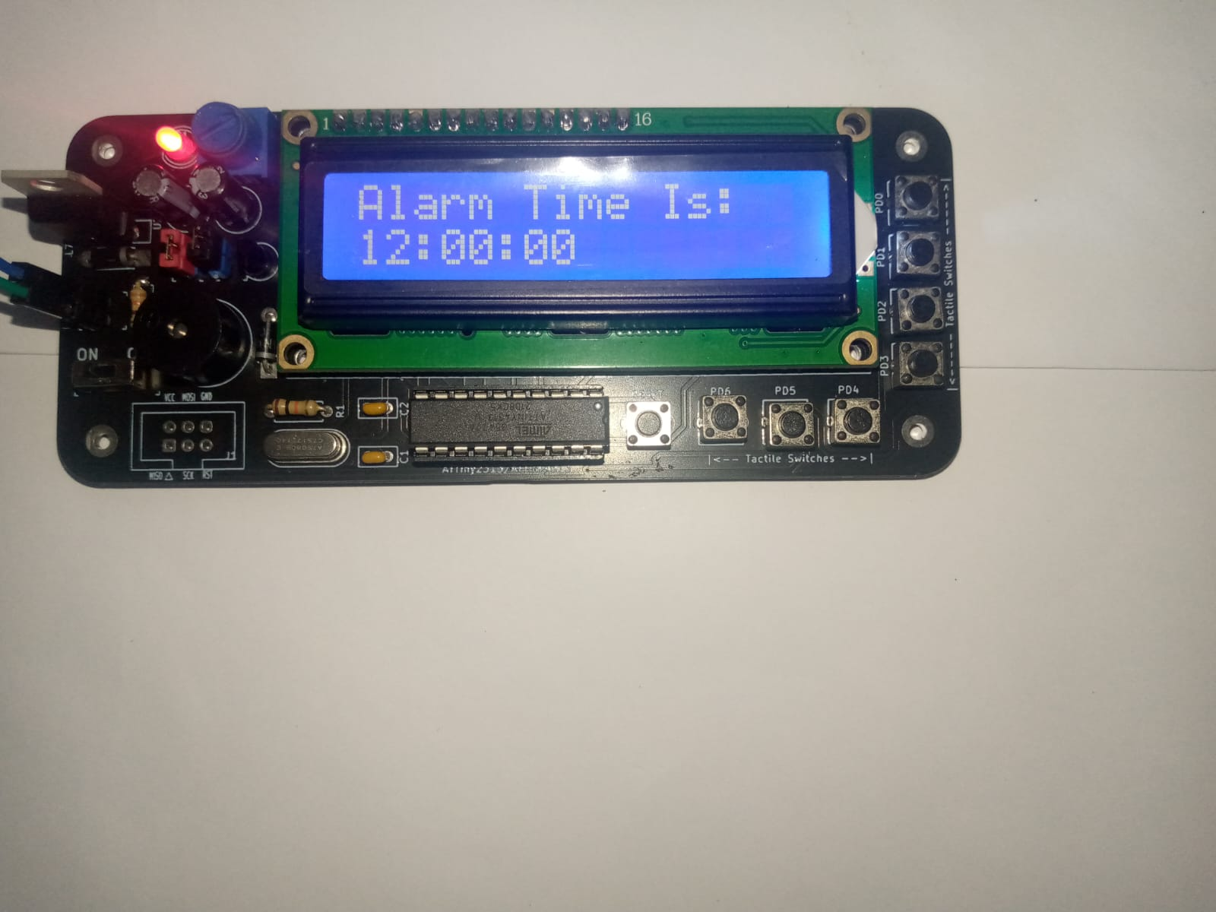

**Figure 27:** Digital Clock Displaying the Alarm Time”

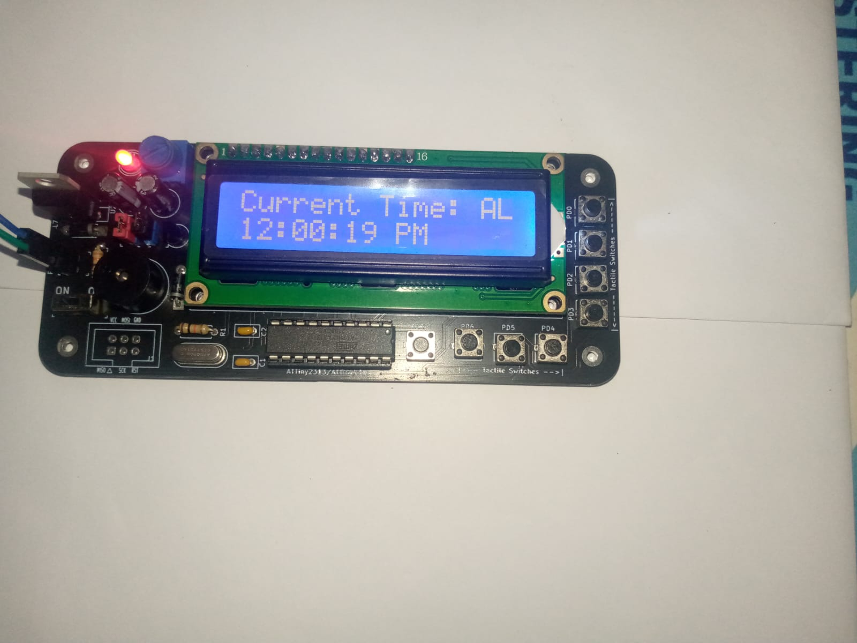

**Figure 28:** Digital Clock Displaying the Current Time with Alarm Enabled

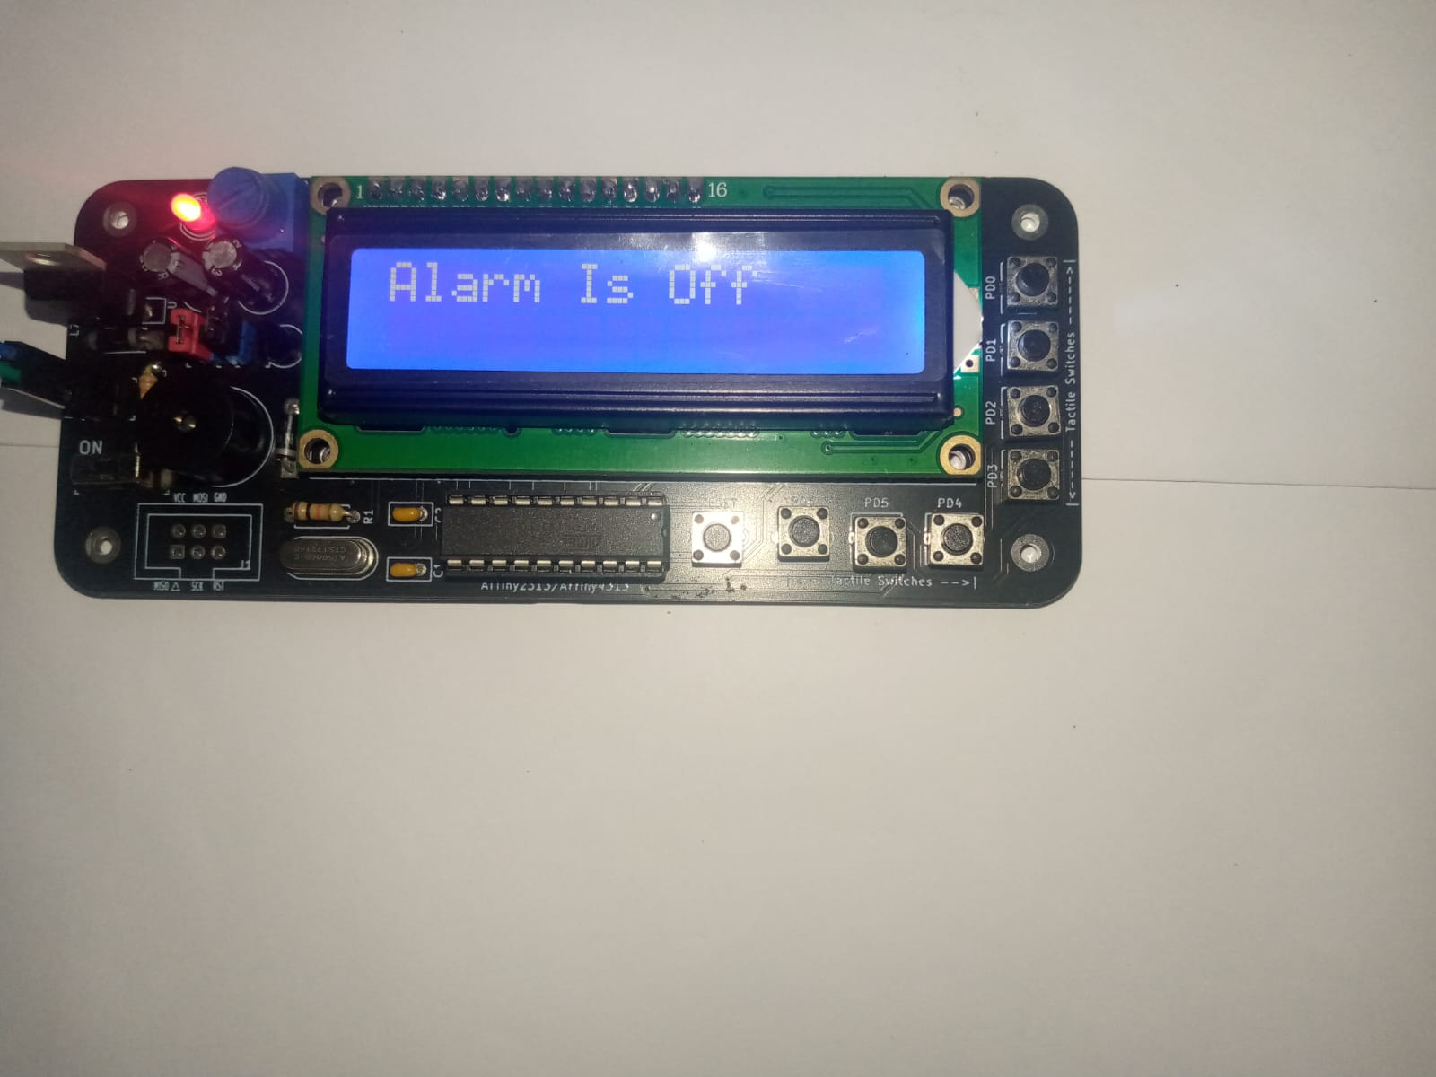

**Figure 29:** Digital Clock Displaying “Alarm Is Off”

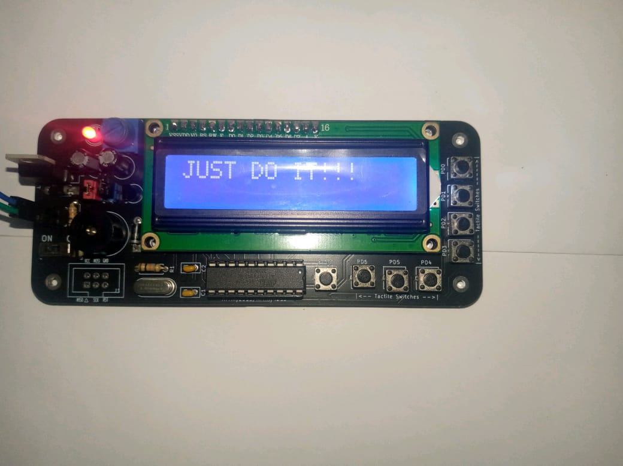

**Figure 30:** Digital Clock Displaying The Motivational Message

**CONCLUSION**

                Microcontrollers are powerful computational devices that work in tandem with a wide variety of components to accomplish a variety of tasks. Future revisions of the hardware and software combination can result in a wide range of possibilities from detecting and displaying environmental variations, 8-bit gaming, or even multilingual display. There were no limitations nor challenges observed as the clock is fully operational. From the results obtained, it can be stated that the digital clock operates as intended. However, the design of the clock can be improved by incorporating a battery holder for the backup and a casing for the clock. Thus, it can be concluded that my Digital Clock was able to meet all of the specifications outlined and shows the potential for more creative and innovative iterations in the future.

**REFERENCES**

ATMEL, “8-bit AVR Microcontroller with 2/4k Bytes In-System Programmable Flash,” ATtiny2313A/4313 datasheet [Revised Sept. 2011]

M.A. Mazidi, Sarmad and Sepehr Naimi, The AVR Microcontroller & Embedded System using Assembly and C, Pearson: Prentice Hall, 2011.

HackaDay.io (2016, Jun. 04). “Tetris on Arduino + LCD” [Online]. Available: https://hackaday.io/project/10761-tetris-on-arduino-lcd

The Arduino Store (N/A). “Clock, Temperature & Humidity Station” [Online]. Available: https://thearduinostore.wordpress.com/kits/68-2/

ELET2405 Experiment 3 (2023)

ELET2405 Digital Clock Project Report (2023)

ELET2405 Information Sheet